Ajinomoto Philippines – Invoicing, Budget, DOA & Supplier Performance Requirements
Workshop Session 3 · Oct 27, 2026 · @Srini

1. Workshop context and scope
Session 3 covered the remaining supplier-facing processes: invoice submission, the annual material budget, approval workflows (DOA), contract and compliance controls, ESG rating and the quarterly supplier performance evaluation. The guiding principle agreed was one platform where suppliers handle RFQs, POs, ASNs, invoices and performance, instead of several systems.
Item | Detail
Client | Ajinomoto Philippines Corporation (APC), Project Beacon
Session | Workshop Session 3 – supplier invoice submission and procurement system consolidation, 27 Oct 2026 (afternoon)
Durvah team | Kishore, Sunit Nighut
Ajinomoto | Chris Ballesteros (Beacon lead), procurement team, procurement manager for packaging materials (owner of the revised performance criteria)
Sessions so far | Day 1 supplier onboarding; Session 2 planning, PR–PO, ASN and GR; supplier risk (26 Oct)
Still to come | Sourcing with procurement (28 Oct), QC and LIMS, contract management, analytics and reports

2. Current process (as-is)
All six processes run on paper, email or Excel. Only cost and receipt data come out of SAP.
A. Supplier invoice submission
- Suppliers deliver physical invoices to the APC office.
- Finance checks each invoice against the PO and goods receipt by hand and posts it. The name of the finance system used today is still to be confirmed.
- Suppliers have no view of invoice or payment status.
B. Annual material budget (per plant, April–March fiscal year)
- Planning provides the annual volume requirement per SKU for the next fiscal year.
- Procurement prepares the budget per plant (two plants plus consolidated) in an Excel template. Prices come from the last PO or from supplier quotations for the next year, which procurement starts collecting in October. Volume is split across suppliers by allocation %.
- Finance reviews it, though not in line-item detail. Planning, procurement and finance then present it to top management for approval.
- The approved budget is fixed for the year. Actuals are tracked against it through a rolling forecast and dashboard.
C. Approvals (delegation of authority)
- Supplier onboarding: procurement, then finance and R&D, before the supplier becomes active (see Day 1).
- Budget: procurement, then finance, then top management.
- PR: approved in SAP by planning, then vendor assignment and PO.
- PR and PO approvers are the same whatever the value. APC has not yet confirmed whether value thresholds apply to sourcing or contracts.
- There is no single documented DOA matrix across processes.
D. Contract and compliance controls (requirement 22: approval controls based on contract validity)
- Intended rule: a PO should not be issued when the price agreement has expired or a key licence (for example the FDA licence) has expired. The supplier is blocked temporarily until a valid document is uploaded.
- For critical materials, the person in charge may override the block and continue issuing POs.
- No system enforces this today.
E. ESG rating
- APC wants ESG ratings at company level and at item level to feed the supplier risk and sustainability score.
- The idea is to integrate external ESG rating sources, or use AI to gather supplier ESG data. Coverage of smaller local suppliers is likely to be thin.
F. Supplier performance evaluation (quarterly, about 50 RM and PM suppliers)
- Procurement compiles a quarterly scorecard in Excel. The criteria were revised this year by the packaging procurement manager.
- Data sources:
  - Cost: from SAP.
  - Quality: from the NC monitoring file kept by QA, covering critical and non-critical defects, defect score and CAR closure.
  - Delivery: from the vendor commitment file, comparing required date with actual receipt date. ETAs come from supplier emails.
  - Audit: today, a supplier not audited this year automatically gets a perfect score. The procedure is being revised to carry over the last audit score until the next audit.
- The revised criteria simplify quality and delivery to two measures: number of NCs against number of deliveries, and on-time delivery (requested date vs actual delivery). Weightings are in the procedure appendix (QCD weighted about 60%, quality about 30%; to be confirmed against the shared document).
- A performance feedback report is approved and signed by the procurement manager and procurement director, printed, and sent to the supplier.

3. As-is process flow
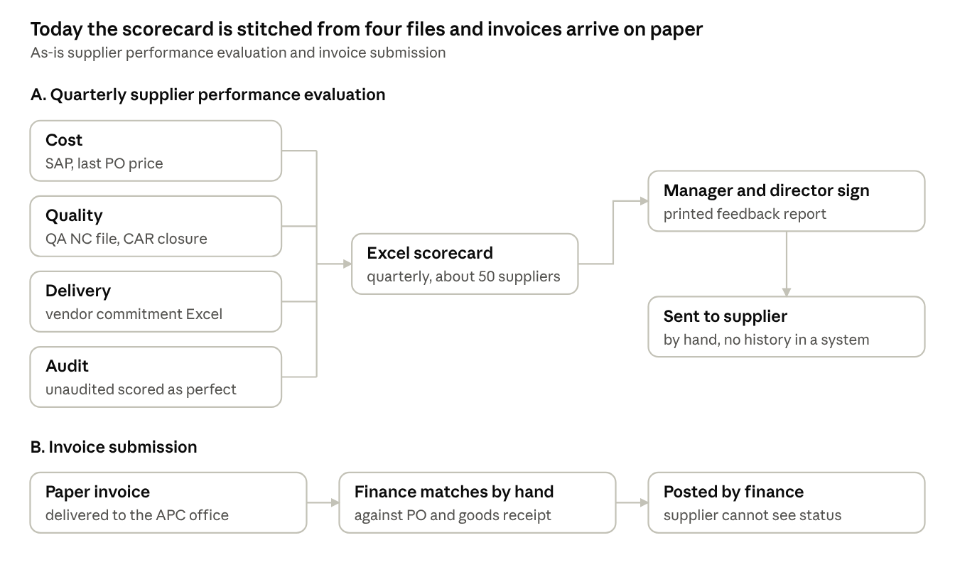
As-is performance evaluation and invoicing · 2 flows
Both flows end with a document handed over in person, so neither APC nor the supplier has a record to look back on.

4. Pain areas
The quarterly scorecard is built by hand from four separate files, so it is slow to produce and only as accurate as the supplier emails behind it.
# | Pain area | Impact
P1 | Invoices submitted on paper at the office; matched to PO and GR by hand | Slow processing; errors in quantity and price; no supplier visibility of status
P2 | Suppliers would use several channels and systems (email, paper, separate portals) | Poor supplier experience; data scattered
P3 | Budget built in Excel per plant; prices from last PO or emailed quotations | Effort each October; price basis not traceable
P4 | Finance review of the budget is high level only | Errors can reach management approval
P5 | No documented DOA matrix across processes | Workflows cannot be configured; approvals inconsistent
P6 | No system block when a price agreement or licence (e.g. FDA) expires | POs can be issued to non-compliant suppliers or at expired prices
P7 | No ESG data on suppliers | ESG cannot feed risk or sustainability scoring
P8 | Scorecard data comes from SAP, the NC file, the vendor commitment file and audit records | Manual compilation every quarter; inconsistent data
P9 | Delivery ETAs come from supplier emails | On-time score depends on manual data
P10 | Unaudited suppliers automatically scored as perfect | Overstated scores (procedure being revised)
P11 | Performance report printed, signed and sent by hand | Slow feedback to suppliers; no history in a system
P12 | NC definitions (critical or non-critical) sit in a separate guideline | Inconsistent classification until LIMS is live

5. To-be process
In the target design, the supplier works in one portal for RFQs, POs, ASNs, invoices and performance. Scorecards come from transaction data rather than Excel, and every approval follows the DOA matrix in the system.
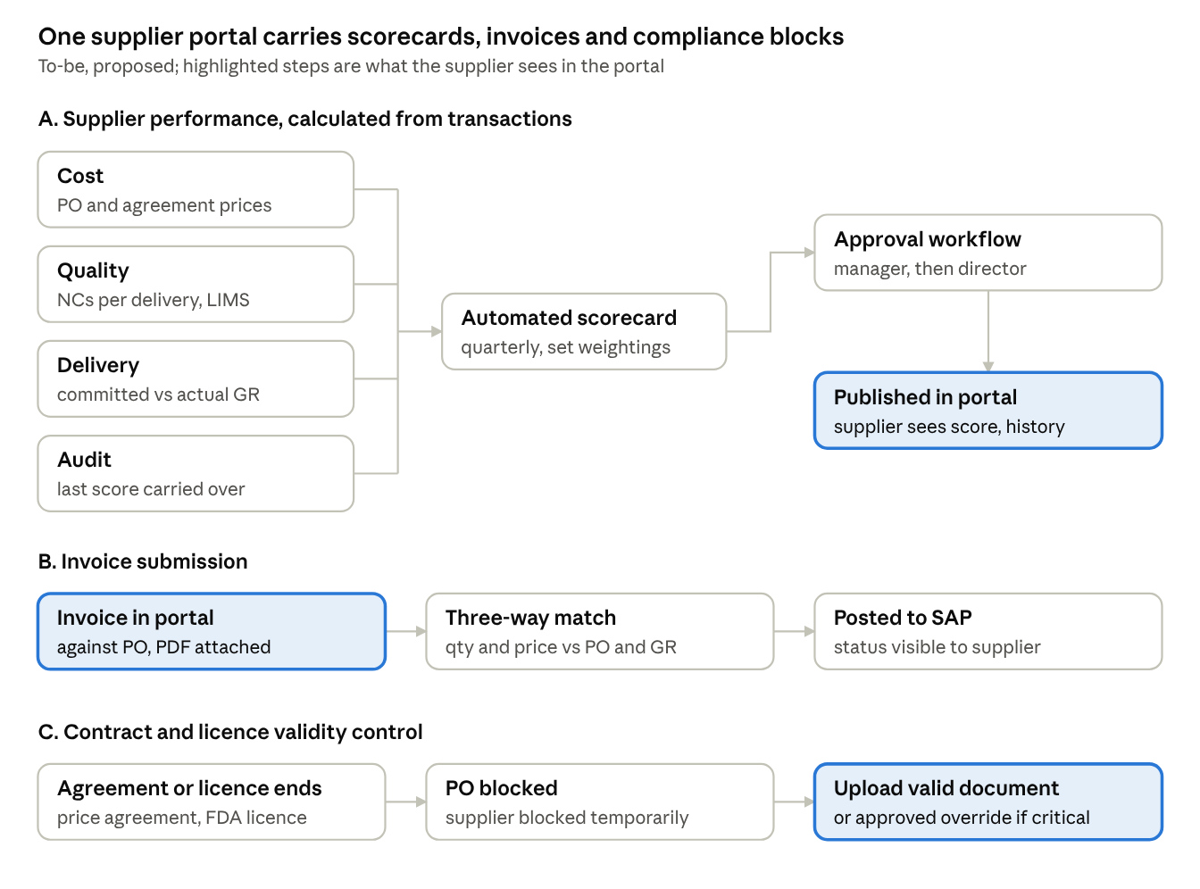
To-be performance, invoicing and compliance control · 3 flows
What changes:
- Performance: the scorecard is calculated each quarter from LIMS NCs, receipts against committed dates, SAP costs and audit scores. The manager and director approve it in the system, and the supplier sees it in the portal.
- Invoices: suppliers submit invoices against POs in the portal. The system matches quantity and price to the PO and GR before posting to SAP. A hard copy is kept only if finance confirms it is required.
- Compliance: an expired price agreement or licence automatically blocks POs. The block lifts when a valid document is uploaded, or by approved override for critical materials.
- Budget: an October e-sourcing round captures next-year prices into the pricing database. The budget then goes through procurement, finance and management approval.
- DOA: one matrix per process drives every workflow, whichever system the step runs in.

6. Functional requirements
Sixteen requirements came out of Session 3. Priorities are Durvah's proposal for Ajinomoto to confirm.
ID | Area | Requirement | Priority
IN-01 | Invoice submission | Suppliers submit invoices against POs in the portal, with the PDF attached; physical copy still accepted if required | Must
IN-02 | Invoice matching | System validates invoice quantity and price against PO and GR (three-way match) and blocks submission until mismatches are resolved | Must
IN-03 | Invoice to SAP | Matched invoices are posted to SAP for finance; invoice and payment status visible to the supplier | Must
IN-04 | Single supplier portal | One login for RFQs, POs, commitments, ASNs, invoices, NCRs and performance | Must
BU-01 | Budget prices | E-sourcing round each October to capture next-year prices from existing suppliers, stored in the supplier pricing database | Should
BU-02 | Budget workflow | Budget per plant prepared by procurement from planning volumes and allocation %, reviewed by finance and approved by top management, with version history | Should
BU-03 | Budget vs actual | Budget fixed for the year, with actual and rolling forecast tracked against it on a dashboard | Should
DO-01 | Configurable DOA | Approval workflows per process (onboarding, sourcing, contract, PO, invoice, performance report, budget), with optional value thresholds and roles | Must
CC-01 | Contract validity control | Block PO creation when the price agreement or contract has expired | Must
CC-02 | Licence validity control | Temporarily block a supplier when a mandatory licence or certificate (e.g. FDA) expires; unblock when a valid document is uploaded | Must
CC-03 | Override | Person in charge can override the block for critical materials with reason and approval; logged | Must
ES-01 | ESG rating | Capture ESG ratings at company and item level, from external rating sources or AI-assisted data gathering, feeding risk and sustainability scoring | Could
SP-01 | Automated scorecard | Quarterly scorecard calculated from transactions: number of NCs vs deliveries (LIMS / WMS), on-time delivery (committed vs actual receipt), cost (SAP), audit score | Must
SP-02 | Configurable criteria | Weightings and scoring bands configurable to match the revised procedure (Appendix B) | Must
SP-03 | Audit carry-over | Last audit score carried over until the next audit; new-supplier audit scores entered from audit planning | Must
SP-04 | Report approval and publishing | Performance report approved by procurement manager and director in the system, then published to the supplier in the portal; no printing | Must

7. Open questions
# | Question | For
Q1 | Which system does finance use today for invoices, and will it stay or be replaced by portal submission? | Finance, IT
Q2 | Must suppliers still submit hard-copy invoices (e.g. BIR rules) after portal submission? | Finance
Q3 | Do sourcing or contract approvals change with value (e.g. above PHP 1M or 3M), or are approvers fixed? | Procurement, management
Q4 | Which licences and certificates trigger an automatic supplier block, and who may override? | Procurement, QA
Q5 | Is ESG rating in phase 1 scope? Which external sources are acceptable? | Chris Ballesteros, management
Q6 | What are the final scorecard weightings and bands after the procedure revision? | Procurement (packaging manager)
Q7 | How are critical and non-critical NCs defined, and will LIMS record the class? | QA – LIMS session
Q8 | When is LIMS scheduled to go live? Until then, where does NC data come from? | IT, QA
Q9 | Should the budget be built in the platform or stay in Jedox / S&OP with prices fed from the platform? | Planning, finance

8. Action items
Eight actions came out of Session 3. The DOA matrix is the one that unblocks workflow design across all processes. Owners are proposed from the discussion; please confirm.
# | Action | Owner | Due | Status
A1 | Share the annual budget template (per plant and consolidated) after senior review | Procurement / Chris Ballesteros | This week | Open
A2 | Prepare the DOA matrix: for every process, the approval steps, roles and any value thresholds, regardless of system | Procurement with finance | Next week | Open
A3 | Send Durvah a sample DOA format (example: contract approval by value band) | Durvah (Kishore) | Today | Open
A4 | Share the supplier performance evaluation procedure with Appendix B, the revised criteria and the NC guideline | Procurement (packaging manager) | This week | Open
A5 | Share the planning MRP / S&OP link and the relation to the budget (from the morning session) | Supply planning | This week | Open
A6 | Confirm the finance invoice system and the hard-copy requirement | Finance | Finance session | Open
A7 | Sourcing session with the procurement team | Procurement, Durvah | 28 Oct | Open
A8 | Consolidate Sessions 1–3 into the detailed requirements and flag RFP items not yet covered | Durvah (Kishore, Sunit) | After workshops | Open

